The Dissolving of Shells Due to a High Rate of CO2
Topic Information: Organisms have shells made of Calcium Carbonate. With a rise in ocean acidity, these shells will dissolve, because there is more Carbon than Calcium in the shells. Organisms will have less energy to rebuild their shells. Which wil lead them to their demise.
Experimental Question: Will shells dissolve faster in sea water or vinegar?
Pre-Lab Questions:
1. How do organisms make their shells? What are shells made of?
Organisms make their shells my putting together calcium and carbon. Shells are made of calcium carbonate.
2. What do you expect to happen to the shell in an acidic solution such as vinegar?
The shell in an acidic solution such as vinegar will dissolve.
3. What are sources of carbon dioxide and which of these sources are most likely to affect ocean pH?
Some sources of CO2 are from exhaling and factories with high CO2 emissions. These emissions are caused by the industrial revolution by the burning of fossil fuel. The exhaling will most likely affect ocean pH. There are about 7 billion people in the world, since you're alive, you're breathing, and breathing requires inhaling oxygen and exhaling carbon dioxide.
Hypothesis: Shells Protocol- If I put a shell into vinegar, then the shell will dissolve, making the shell more brittle than the shell placed into salt water. Vinegar has an acid pH, and acid dissolves the shells of organisms.
Protocol: First, measure the mass of the shells already put in an acidic solution long before the experiment. Record the data of before (given) and after. Observe the shells. Measure the mass of two untreated shells. Observe the shells. Record the data of 'before'. Using a permanent marker, place a 'C' for control on one shell, place an 'E' for experimental on the other. Place the C shell in a 200mL beaker of 100mL sea water. Place the E shell in a 200mL beaker of 100mL vinegar. Time the experiment for 30 minutes and take notes every 15 minutes. After 30 minutes, take the shells out, and record mass for 'after'. Observe the shells. Test the strength by using textbooks, placing them on top and count the amount it takes to crush them.
The dependent variable is the mass of the shells.
The independent variable is the type of liquid the shells are put in.
Constants are the beakers used, and the amount of liquid put in each.
Data: 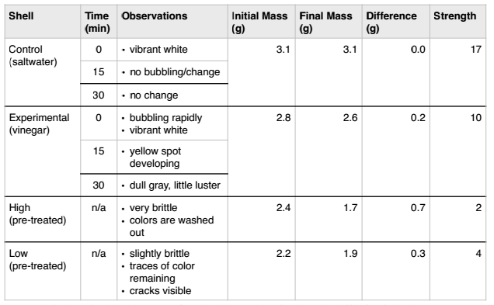

Data Analysis:
1. When you immersed the shells in vinegar how did you know that a reaction was happening?
When I immersed shells in vinegar, I knew that a reaction was happening because there was a bubbling effect on the shell.
2. How did observing the shells in vinegar relate to how animals are affected by a lower pH of ocean water?
These shells show us how this is a global problem in the oceans. The dissolving of the shells in an acidic solution simulates what happens at a global scale, with CO2.
3. How would shelled organisms be affected by a lower pH of ocean water?
The shelled organisms’ shells will dissolve because of the low pH of ocean water.
4. What are the primary functions of shell for these animals?
The functions of the shells are for protection and shelter.
5. Does it cost the animal energy to rebuild or repair their shell?
Yes, it does cost the animal energy to rebuild shells.
Conclusion: My initial hypothesis was true, because the mass of the shell in the vinegar went down. The shell in the seawater went up by .1, sea water has a neutral pH of 7. Without shells of organisms globally, these organisms will be easy prey, but not only does it affect the shelled organisms, but it affects the whole ocean of fish. Without these shells, the organisms will be more vulnerable, which means the rate of them being eaten will go up, and the population will go down. Some of these shelled organisms play a key role in the survival of all fish. Without the fish, all the other fish in the food chain will die out.

