

October 2014, Ethan Tran

The Amur Leopard (Panthera Pardus Orientalis)  
The Amur leopard can run at speeds of up to 37 miles per hour. This incredible animal has been reported to leap more than 19 feet horizontally and up to 10 feet vertically. They live in Temperate, Broadleaf, and Mixed Forests in Amur Heilong. The Amur Leopard’s major reason for its endangerment was its spotted fur that was love by many in Amur-Heilong. Also, in China the prey base is insufficient to sustain large populations of leopards and tigers.

Hawaiian White Hibiscus (Hibiscus Waimeae)  
The Hawaiian White Hibiscus is a small, gray-barked tree up to 30 feet tall. The upper surface of the leaves is light green while the lower surface is covered with velvety hairs which make it appear grayish. The round or oval leaves are 2 to 7 inches long and 1 to 5 inches wide. The single flowers last only one day. They are white when they open in the morning and they fade to pink in the afternoon. The flowers occur towards the ends of the branches and have a strong, sweet fragrance. The staminal column is pink to crimson. It grows in the moist forests of Kaua'i from 800 to 3,900 feet. Because Hibiscus species hybridize readily, the unique characteristics of Hibiscus waimeae are threatened by cross-pollination with non-native Hibiscus varieties that have been introduced to Kauai for ornamental use.

Chinese Giant Salamander (Andrias Davidianus)  
The Chinese giant salamander is the largest living species of amphibian, reaching a maximum length of 1.8 meters. It’s located in Central, south-western and southern China. It lives in cool, fast-flowing streams and mountain lakes and predominantly feeds on fish and crustaceans. This species is threatened by over-harvesting for the food trade, as well as the destruction and degradation of its habitat.

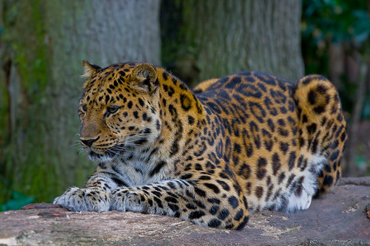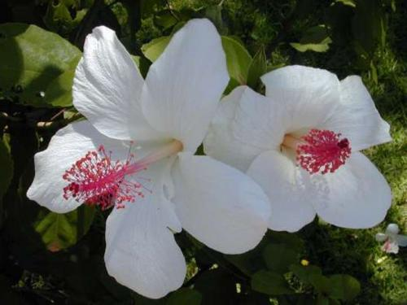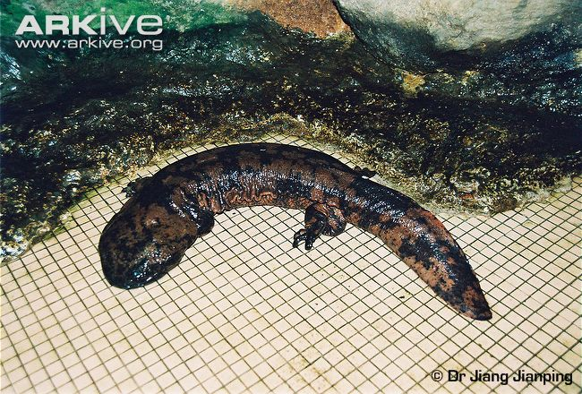

Here Now, Gone Tomorrow

Endangered Species

Continue newsletter text here. Continue newsletter text here. Continue newsletter text here. Continue newsletter text here. Continue newsletter text here. Continue newsletter text here. Continue newsletter text here. Continue newsletter text here. Continue newsletter text here. Continue newsletter text here. Continue newsletter text here. Continue newsletter text here. Continue newsletter text here. Continue newsletter text here. Continue newsletter text here. Continue newsletter text here. Continue newsletter text here. Continue newsletter text here Continue newsletter text here

Continue newsletter text here. Continue newsletter text here. Continue newsletter text here. Continue newsletter text here. Continue newsletter text here. Continue newsletter text here. Continue newsletter text here. Continue newsletter text here. Continue newsletter text here.

Continue newsletter text here. Continue newsletter text here. Continue newsletter text here. Continue newsletter text here. Continue newsletter text here. Continue newsletter text here. Continue newsletter text here. Continue newsletter text here. Continue newsletter text here. Continue newsletter text here. Continue newsletter text here. Continue newsletter text here.

Continue newsletter text here. Continue newsletter text here. Continue newsletter text here. Continue newsletter text here. Continue newsletter text here. Continue newsletter text here.

Continue newsletter text here. Continue newsletter text here. Continue newsletter text here. Continue newsletter text here. Continue newsletter text here. Continue newsletter text here. Continue newsletter text here. Continue newsletter text here.

Continue newsletter text here. Continue newsletter text here. Continue newsletter text here. Continue newsletter text here. Continue newsletter text here. Continue newsletter text here. Continue newsletter text here. Continue newsletter text here. Continue newsletter text here.